CNS 1410 Object-oriented Programming

Programming Project 5: Recursion

Due Date:
Must be submitted no later than 1:00am next Monday.
Programs received prior to 1:00am on Sunday will receive 5 bonus points, if the program executes correctly.

Objective:
Create and test a recursive function.

Project:
Use recursion to implement a function
int index_of(string s, string t).
The function locates the first instance of the string t within the string s, and returns the index of the starting position in s where this substring occurs.
For example, if
s = "goodbye" and
t = "bye",
then the function will return the value 4. Your function must handle the case where the second string is not found. One way of doing this is to return -1, since this would be an invalid index.
Your program must use recursion. You may not use the find() function that is provided in the string class. Since you must keep track of how far the match is from the beginning of the string s, consider changing the problem slightly so that your index_of( ) function calls a recursive helper function that takes that value as one of its parameters.
Your main( ) routine should prompt the user for two strings. It will then report where the second string is found within the first.
Format and document your code in accordance with the course style guidelines. Include a file prologue identifying you as the author. Submit your project using the instructions outlined in the Course Syllabus, Programming Projects section.

File(s) to Submit:
- recursion.cpp
- recusion.exe

Grading
The Grade sheet is here

Sample Output:
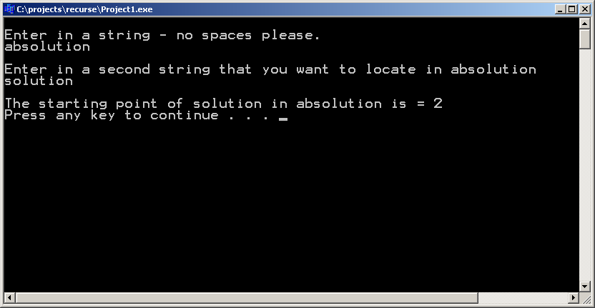
You can get an executable that runs correctly here!

